Web-Development IWED5112 Part 1

ST10473403 Dihan Haarhoff

Table of Content

* Table of Figures 1
* Bibliography 1
* Motivation for developing a website for cycling coaching 3
* The objectives of having a website for this business. 3
* List the resources you will need to assemble for the creation of the website 3
* Target market by establishing a User Persona for this brand. 4
* Site map for the web page 5
* Fotos used in this project 6

# Table of Figures

* Figure 1Ace Fitness February 2024 Should health coaches specialize February 2024 Ace Fitness by Dr. Erin Nitschke 5
* Figure 2 MTB Skills Coaching 1to 1and exclusive sesions 5
* Figure 3 Moonshot coaching 5
* Figure 4 Finally a victory' - Tadej Pogačar wins first race of 2025 with mountaintop sprint at UAE Tour- Cycling Weekly 2025 19 February by Tom Davidson 6
* Figure 5 NZ cycling loses top coach 30 May 2018 RNZ 6
* Figure 6 Training Peaks 6
* Figure 7 Instagram Logo Freepik 7
* Figure 8 Home page before change 8
* Figure 9 Home page after change 8
* Figure 10 Before change was made of heading and picture 9
* Figure 11After Change was made to heading and picture 9
* Figure 12 Before heading and underlined words was changed 10
* Figure 13 After heading and underlined words was changed 10
* Figure 14 Before the cart page was changed 11
* Figure 15 After the cart page was changed 11

# Part 1:

# Motivation for developing a website for cycling coaching

It helps all cyclists to get access to cycling coaching no matter where they are. It will serve as an platform to help cyclists get stronger, fitter and boost their knowledge about nutrition and techniques. It could create a community full of like-minded people.

For a coach a website enables them to grow their business by reaching more people.

# The objectives of having a website for this business.

The website will serve as 24/7 marketing for the business witch can attract new clients. By establishing the website you can showcase your experience, clients and certification which then can establishing the business as a experienced and trusted coach. It can allow easy communication between the clients and the coach.

(What Are The Benefits Of A Website For Small Business, 2024)

# List the resources you will need to assemble for the creation of the website

1. A custom logo that can show the brand identity
2. Fotos of the coaching staff
3. Coaching foto’s both team and individual
4. A brief introduction of the services that can be provided
5. Ways to be contacted
6. A checkout system
7. Pricing page with the different categories and the prices
8. Testimonials of the clients reviews and success stories
9. A memorable domain name
10. A reliable web host to ensure that the business is fast and secure
11. A platform the build, maintain and manage the website

# Target market by establishing a User Persona for this brand.

# 

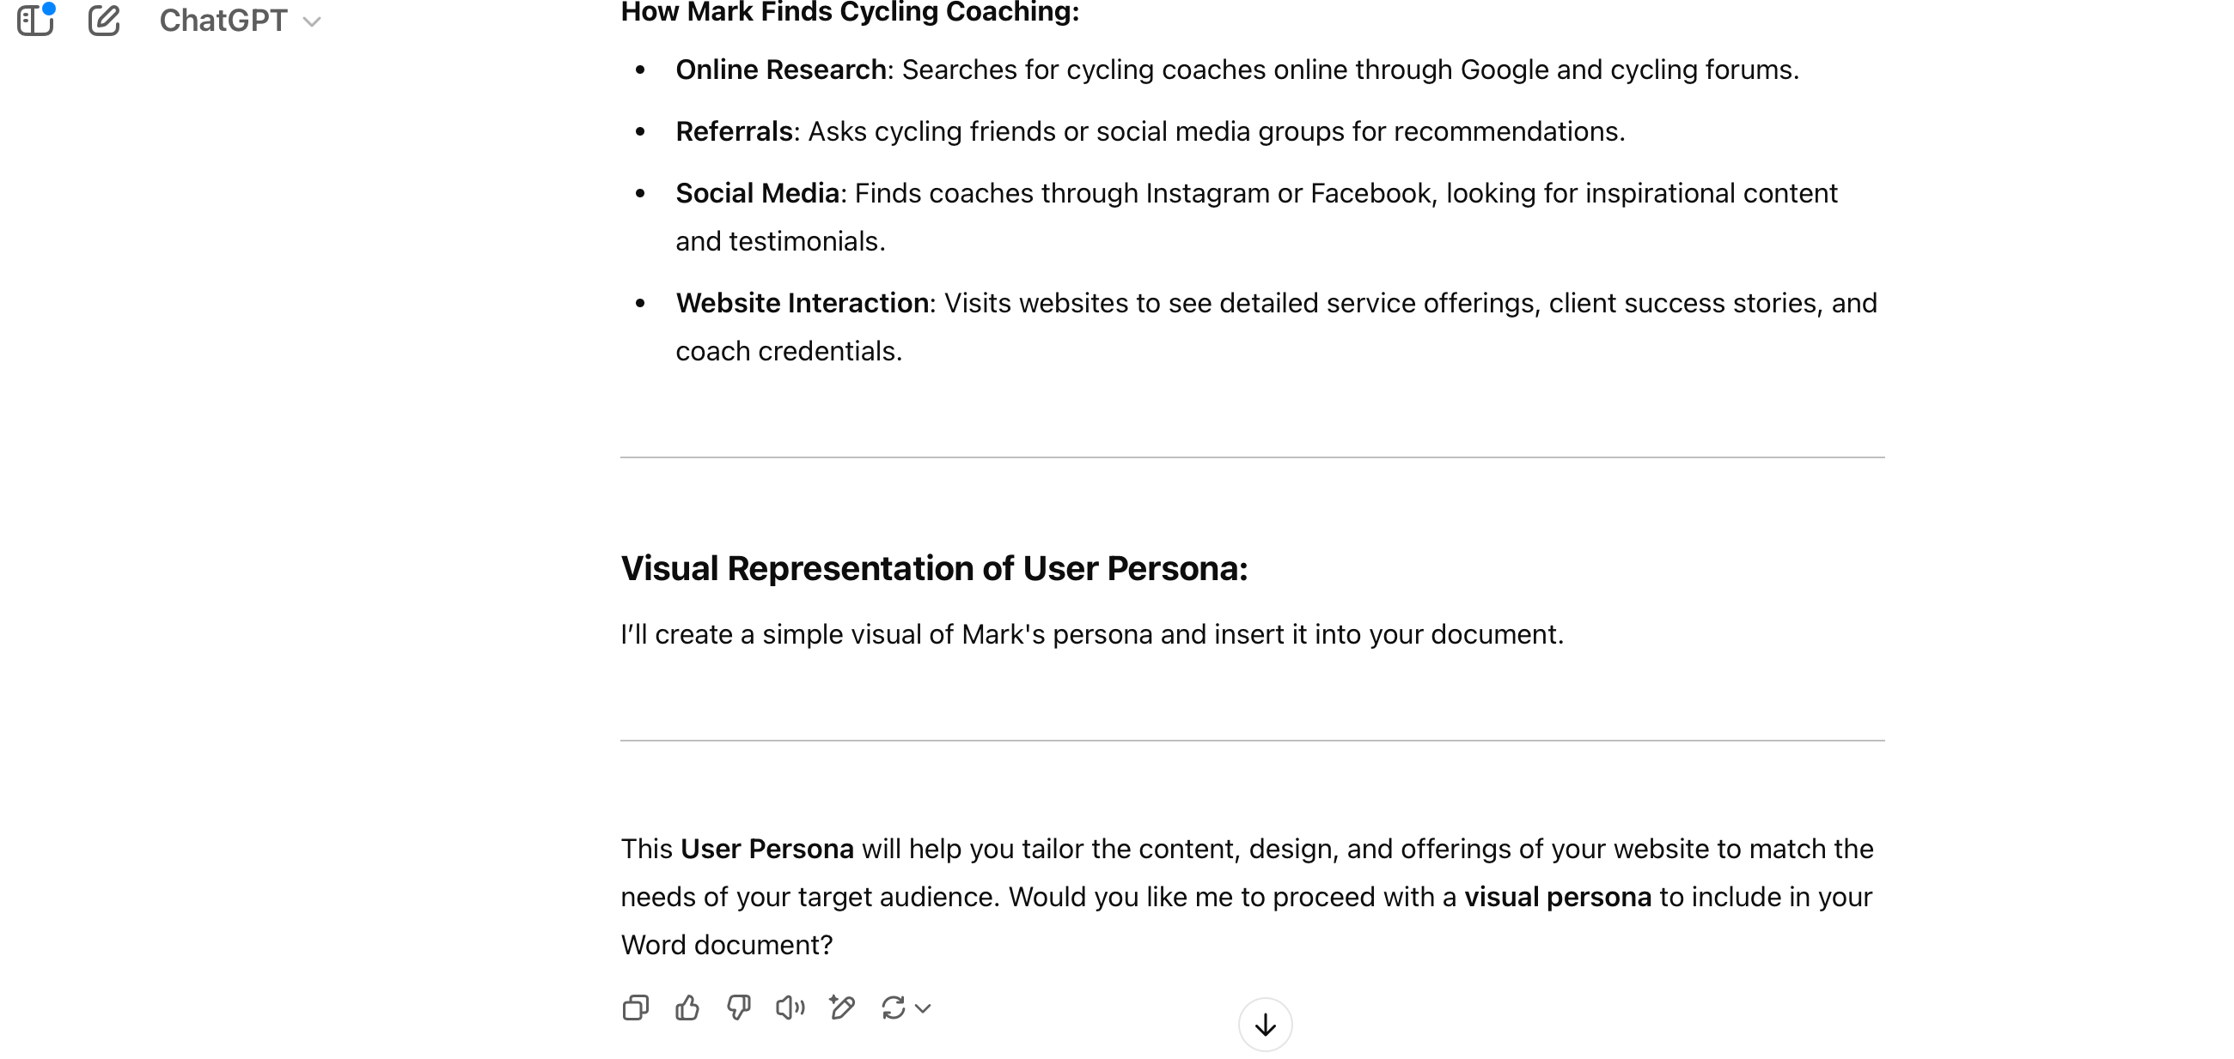 (Anon., 2025)

# Site map for the web page

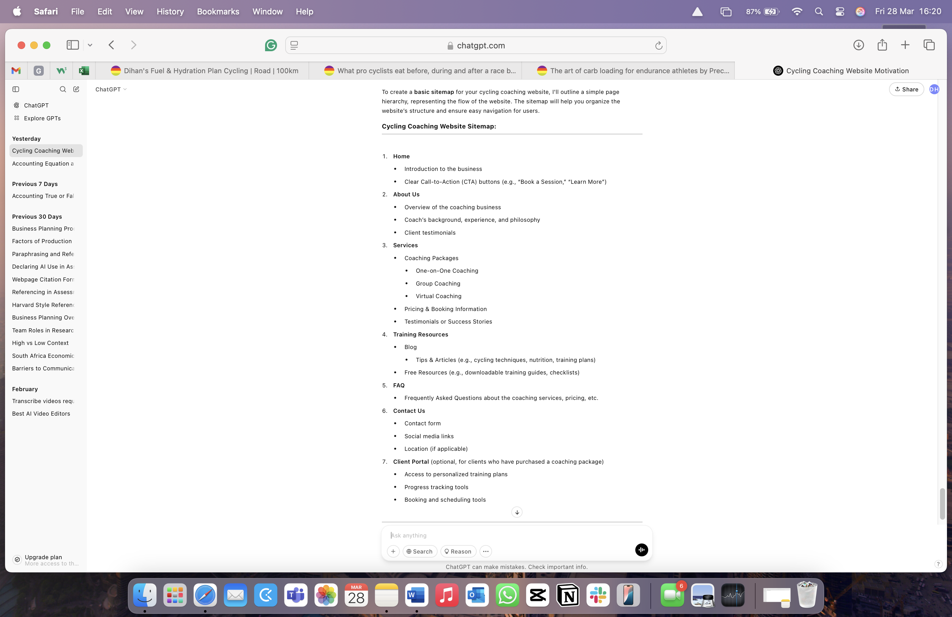 (Anon., 2025)

# Bibliography

* *What Are The Benefits Of A Website For Small Business.* 2024. [Film] Directed by Ronald Osborne. s.l.: s.n.
* Anon., 2025. *Chat GPT: User persona for a cycling coach.* [Online]   
  Available at: chatgpt.com [Accessed 27 March 2025].
* Anon., 2025. *Site map for cycling coaching website.* [Online]   
  Available at: chatgpt.com  
  [Accessed 28 March 2025].

# Fotos used in this project

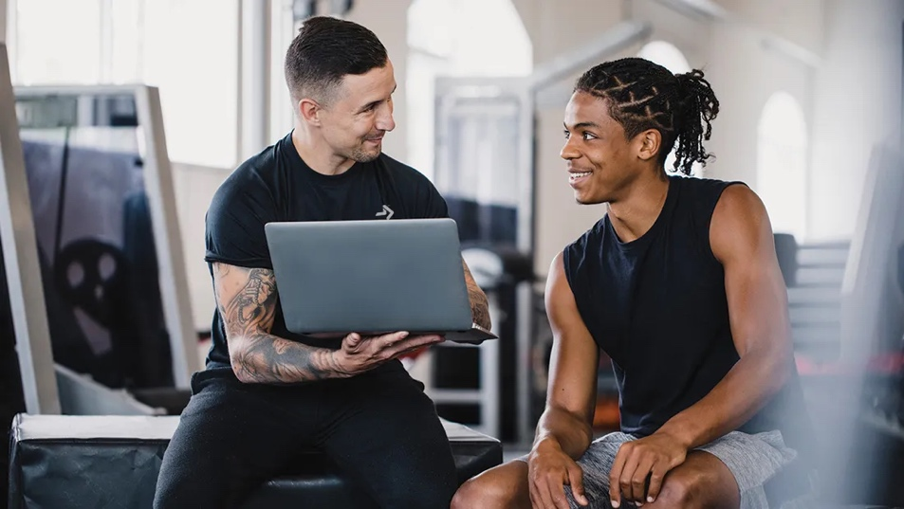

Figure Ace Fitness February 2024 Should health coaches specialize February 2024 Ace Fitness by Dr. Erin Nitschke

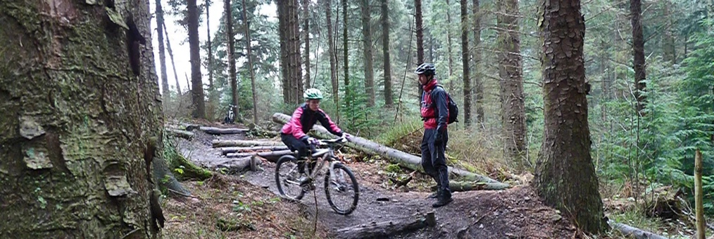

Figure MTB Skills Coaching 1to 1and exclusive sesions



Figure Moonshot coaching

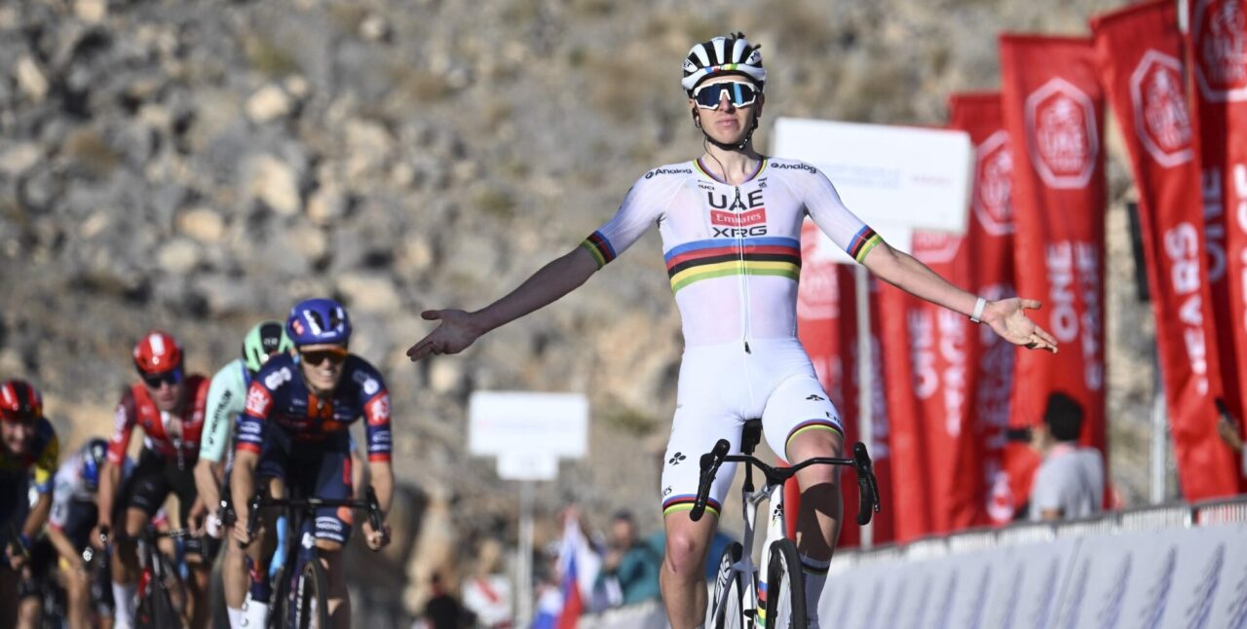

Figure Finally a victory' - Tadej Pogačar wins first race of 2025 with mountaintop sprint at UAE Tour- Cycling Weekly 2025 19 February by Tom Davidson

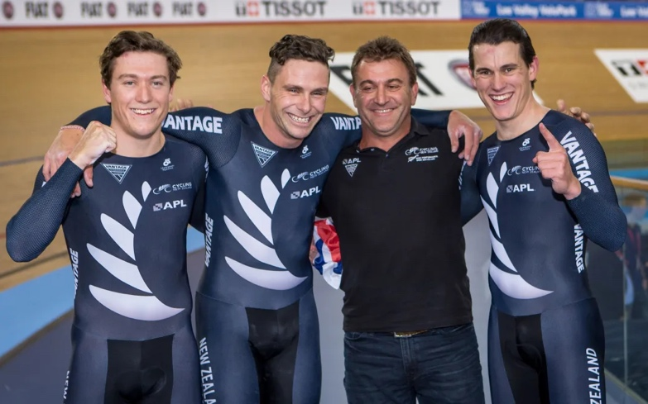

Figure NZ cycling loses top coach 30 May 2018 RNZ

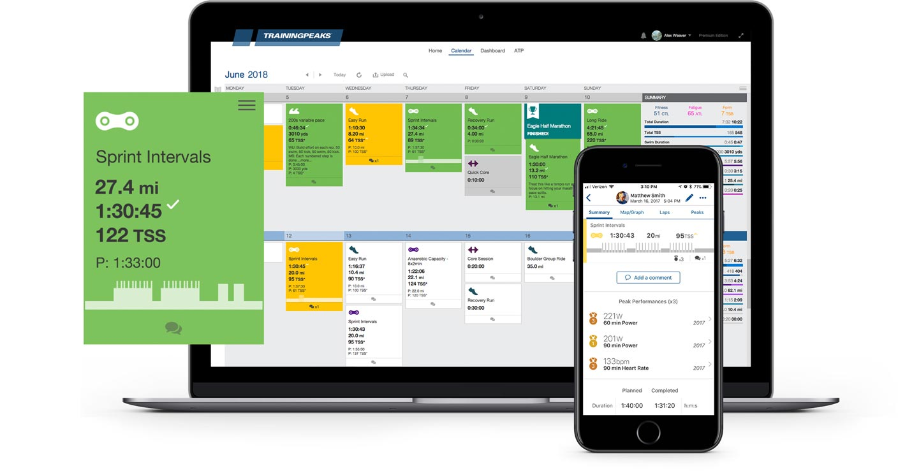

Figure Training Peaks



Figure Instagram Logo Freepik

# Part 2:

# Refinements and improvements from Part 1 Feedback and Reflection

* The navigation buttons I changed to pseudo button selectors, added a hover, focus so that it would make it easier for the user to know what button the are choosing and made a gap between the navigation and the first photo to make it look better

Before:

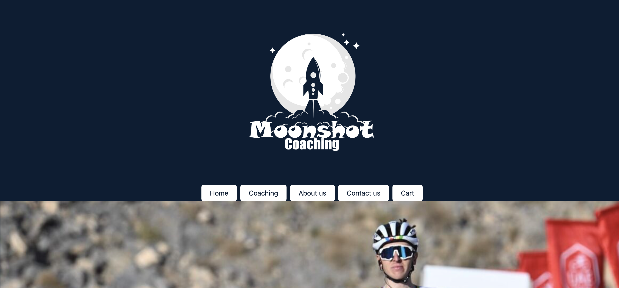

Figure Home page before change

After:

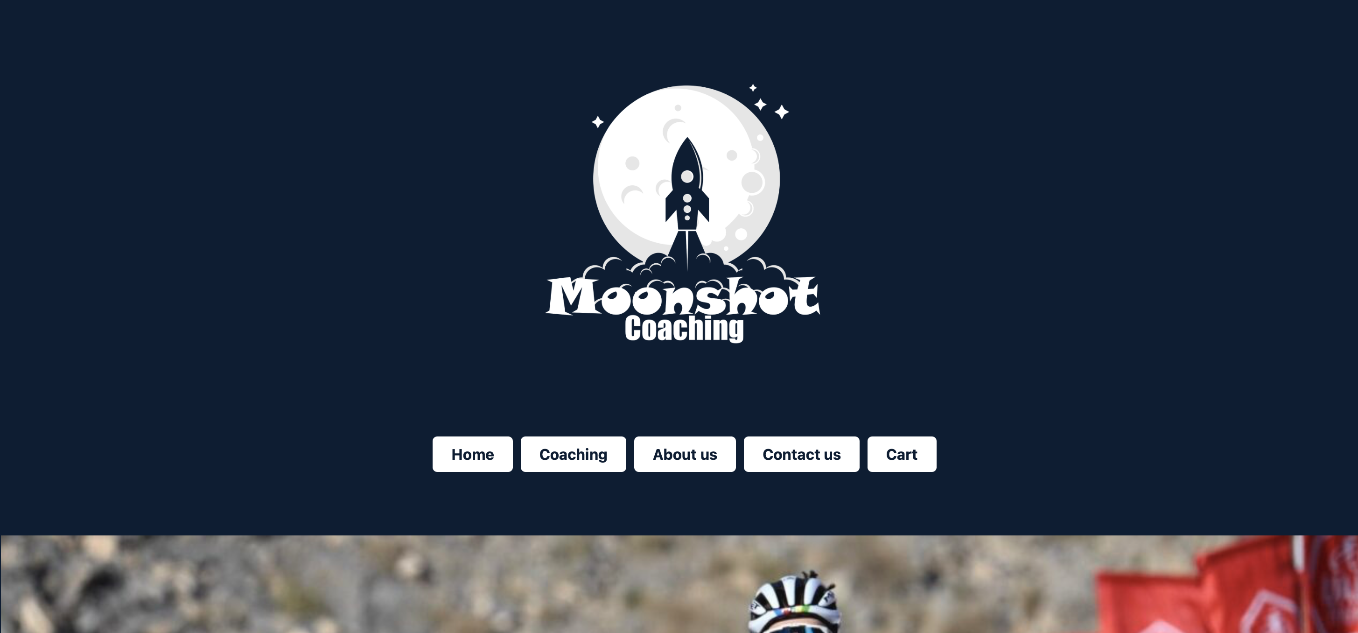

Figure Home page after change

* Changed the heading sizes to make it easier to read and also made the pictures fill up the website more so that it gives you a feeling that you are there.

Before:

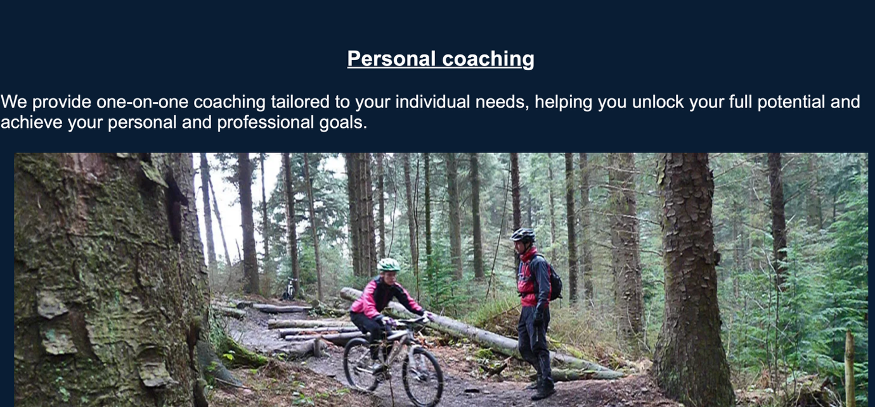

Figure Before change was made of heading and picture

After:

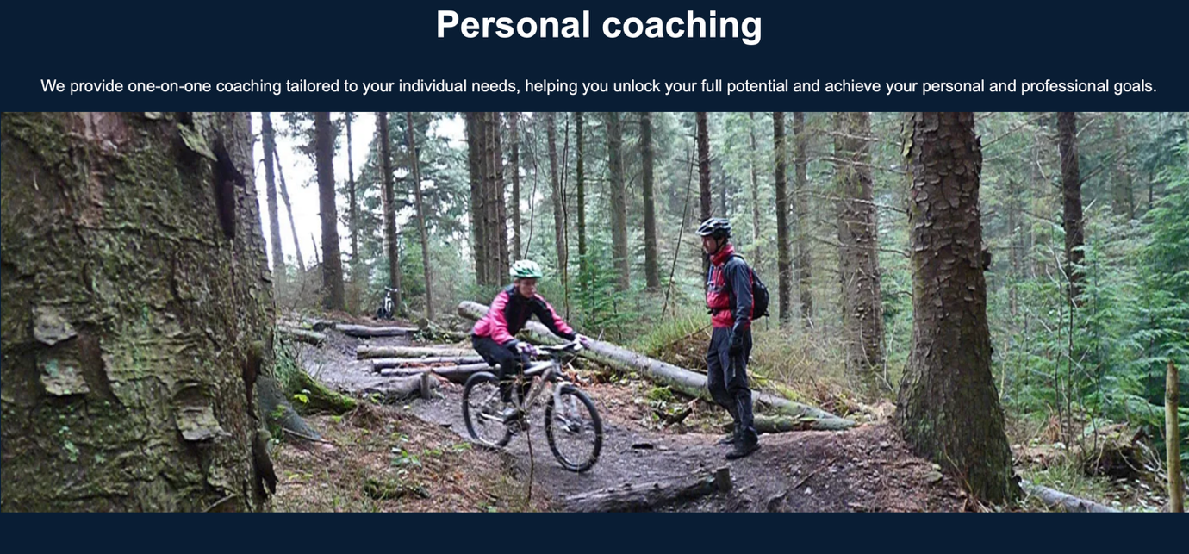

Figure After Change was made to heading and picture

* Removed some of the headings and underlined words witch gives it a more clean look.

Before:

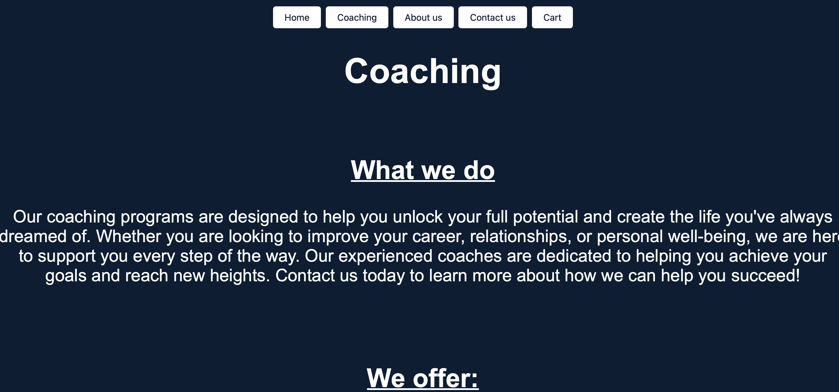

Figure Before heading and underlined words was changed

After:

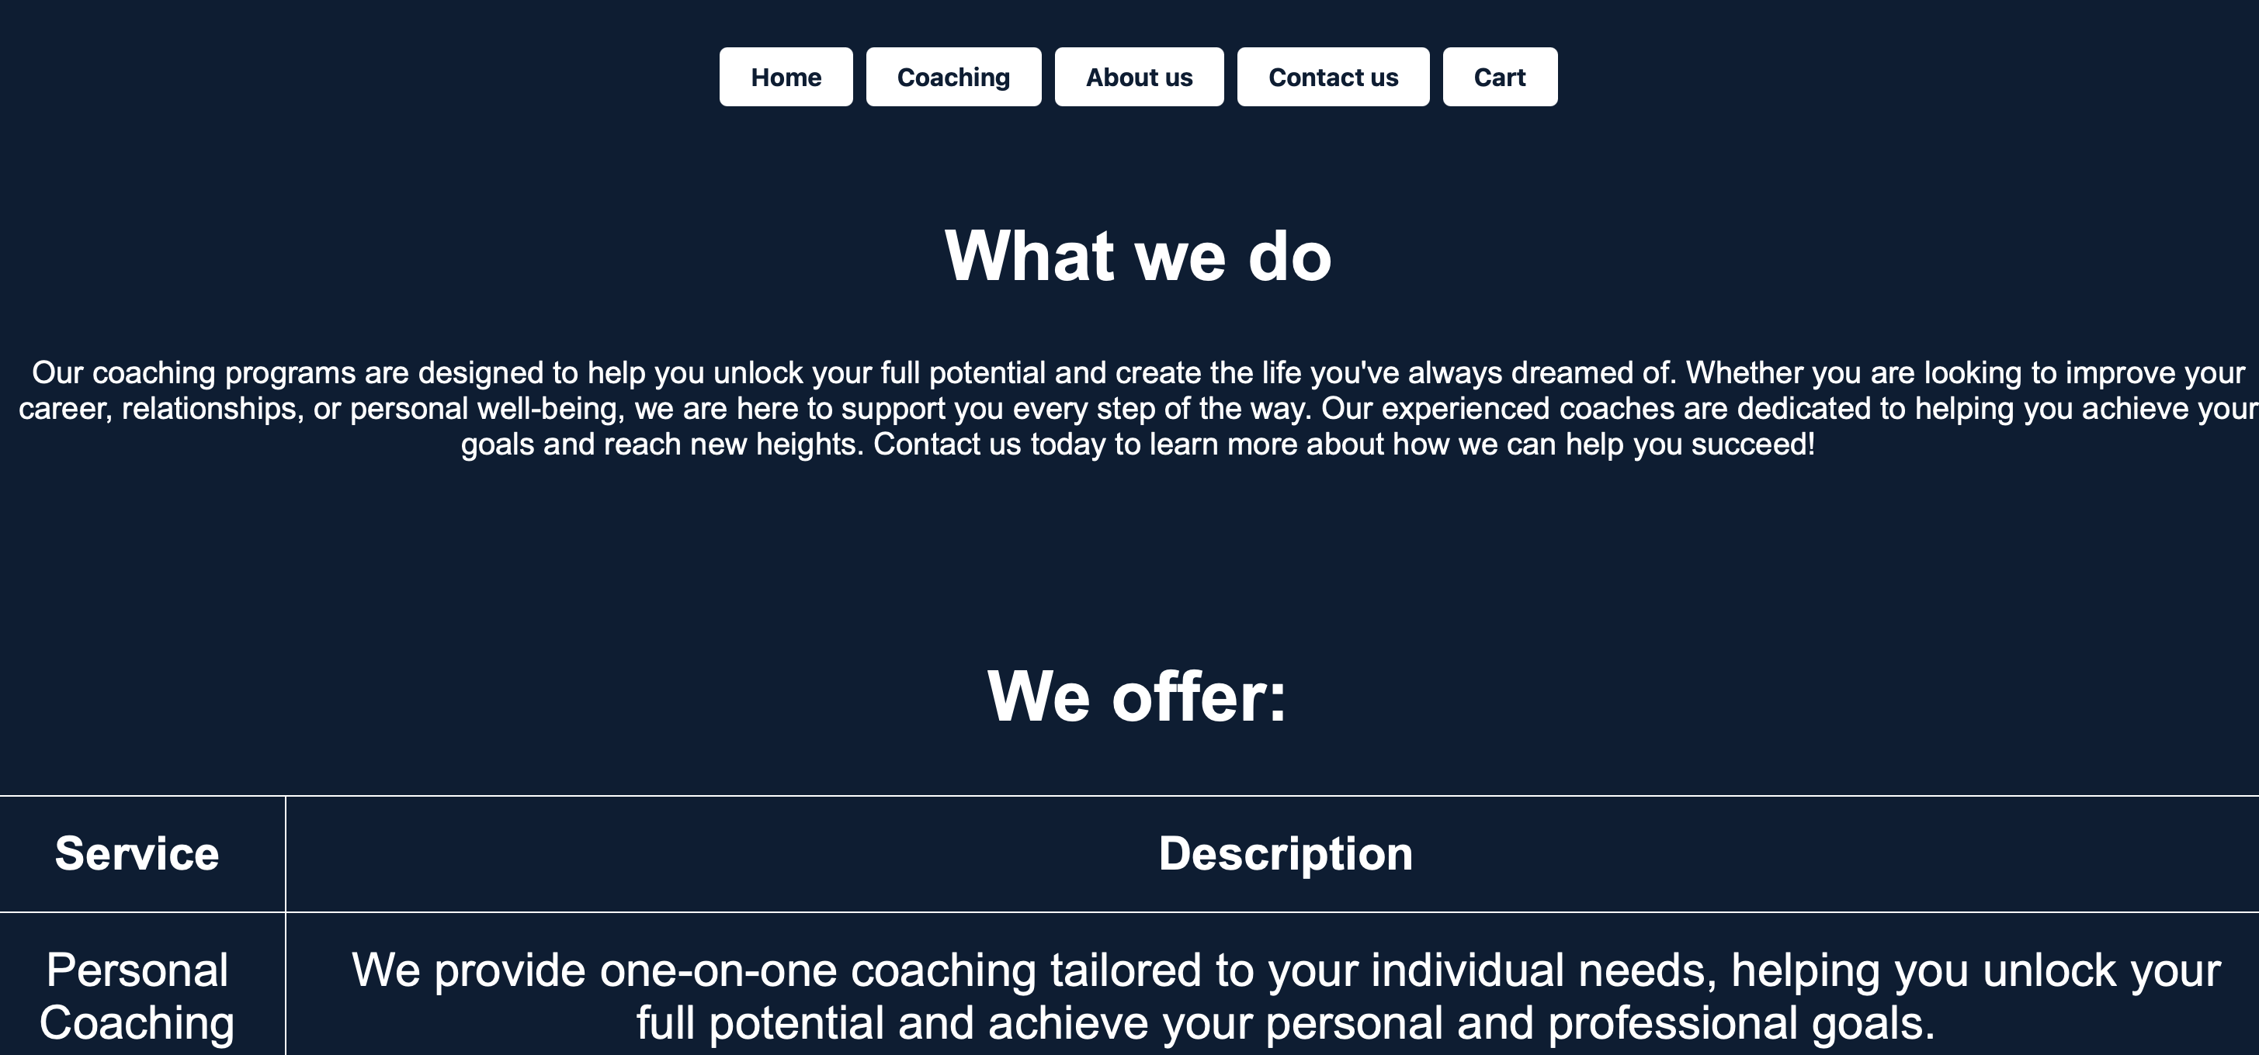

Figure After heading and underlined words was changed

* The Cart page was to cluttered and made it look much neater.

Before:

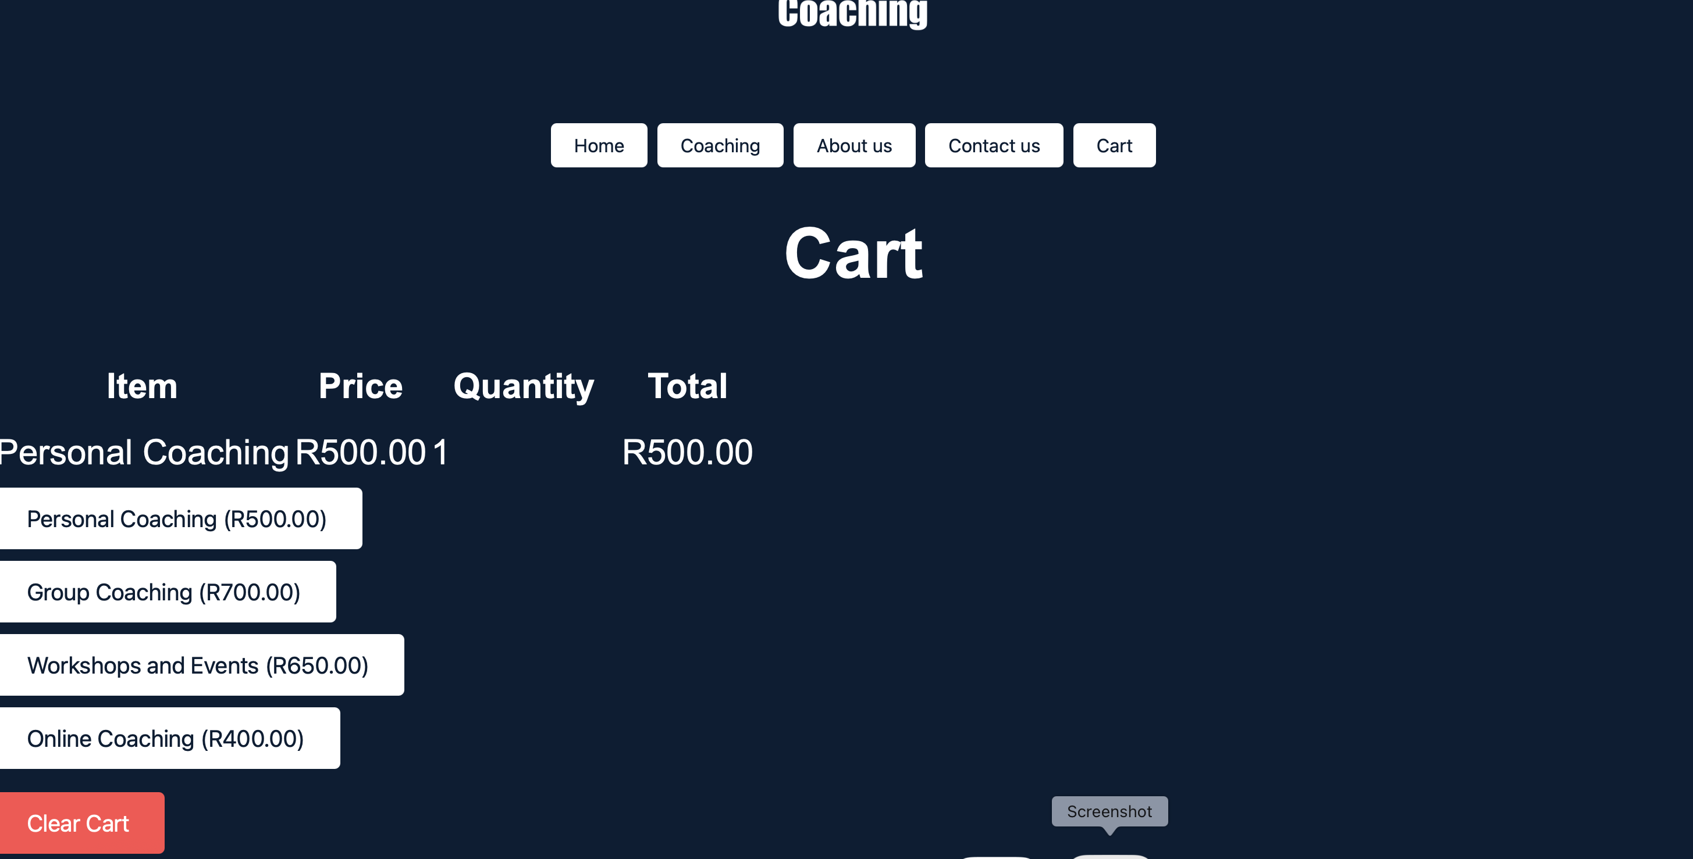

Figure Before the cart page was changed

After:

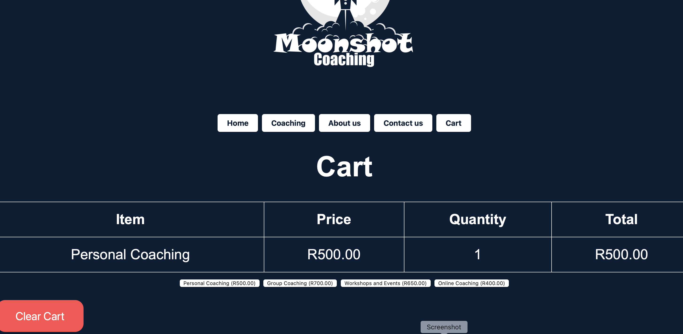

Figure After the cart page was changed

# Part 3

# Refinements and Improvements from Part 2

* Made the heading, text and picture come forward and the back dims, which makes the website more engaging.

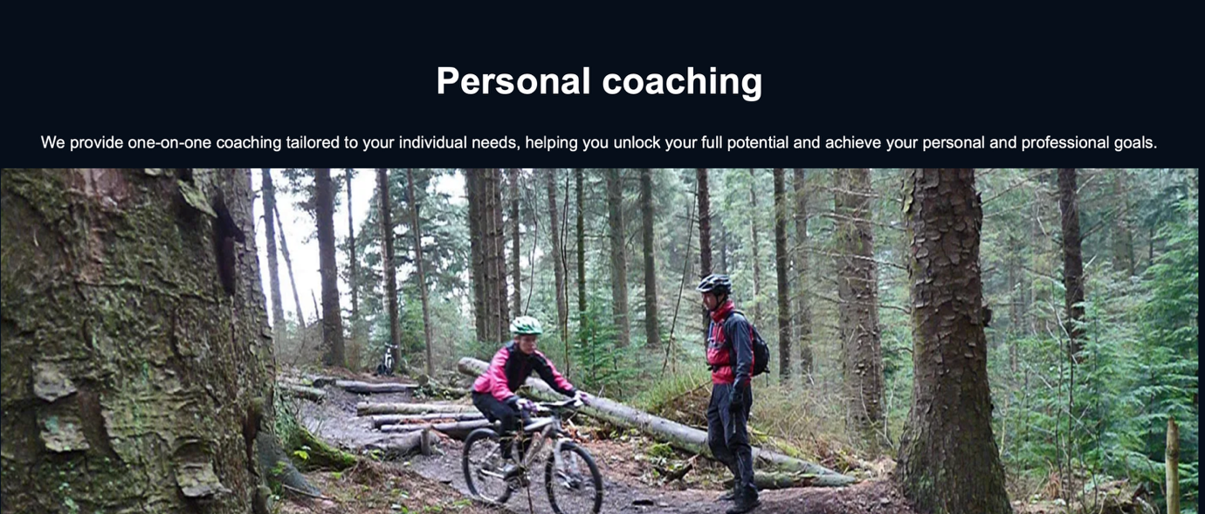

Figure : After the change to picture and text



Figure 17: Before the change to picture and text

# Implementation of JavaScript

* Implemented JavaScript on the home page so that when the user scrolls down, the photos and texts pop up and the background dims, making it more attractive and engaging for the user.
* Implemented JavaScript on the Contact Us page so that when the user enters an email, it will tell the user if the email address is not valid, to use a name and that the message should be 10 characters.